# Creating a Remote Connection(TigerVNC) Rev 4.1

## Overview:

In this activity, you will connect to your Raspberry Pi and complete configuration steps so that you will have remote access to your piRover. You’ll download and install the required software on your computer system and make your first remote connection into the system.

## Prerequisites:

Prior to beginning the instruction provided in this lesson you must have completed the following:

1. piRover build and test

## Performance Outcomes:

1. Connect to a Wi-Fi access point.
2. Edit a configuration.
3. Modify the Wi-Fi access point name and authentication.

## Resources:

1. 2024 piRover kit with K2 microSD card image
2. NMC Wi-Fi Access Point (AP)
   1. SSID: **NMC-PSK**
   2. PSK/password: **Baffle-Amused-Stencil4**

## Materials:

1. Wi-Fi access point
2. Laptop or Workstation with Ethernet network connection
3. Ethernet cable (provided in kit)
4. Ethernet cable adapter (requirement discussed in week 1)
5. [TigerVNC](https://sourceforge.net/projects/tigervnc/)
6. [Bonjour Print Services for Windows](https://support.apple.com/kb/DL999?locale=en_US)

## Directions:

1. A typical setup for a Raspberry Pi single-board computer is shown in Figure 1. Note the USB-C power connection in addition to the USB Dongle providing keyboard and mouse connectivity. A small HDMI monitor is displaying the Pi desktop and requires the Micro-HDMI cable included in your kit.

Figure - RPi Single Board Computer Setup

1. In this class, you are connecting to the Raspberry Pi integrated into your piRover system. Typically, you will not have a monitor, keyboard, or mouse directly connected to the Pi, but these components may be required if you are having issues connecting. Normally you will connect using a remote desktop service (VNC) running on the Pi. This is often referred to as “headless mode.”
2. In this activity, you make your first connection to the RPi using the Ethernet cable provided. Eventually you may be able to connect using Wi-Fi connectivity and the Ethernet connection is not required.
3. The first step in making the remote connection is to connect the piRover to your computer using the Ethernet cable provided.

1. Recall that if your computer does not have an Ethernet port, a USB to Ethernet adapter is required like the one shown below. This requirement was discussed during the first week of class.

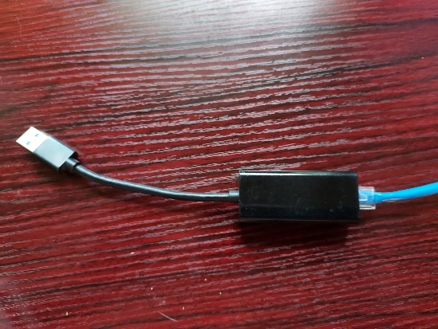

Figure Ethernet to USB adapter

1. You’ll be creating a peer-to-peer network connection between your workstation and the Raspberry Pi. If you are using a Windows PC an additional software driver is required to make this type of connection. If you are on a PC, navigate to this [Bonjour Print Services for Windows](https://support.apple.com/kb/DL999?locale=en_US) link. Download Bonjour Print Services for Windows from [this link](https://support.apple.com/downloads/bonjour_printer_services). Install the driver. This step is not required if you are using an NMC workstation in a PS lab.

Figure Bonjour Print Services for Windows

1. You’ll use VNC remote desktop software to provide the remote connection. The RPi system provided for you has the VNC server feature enabled as shown below, but you must install the TigerVNC client on your workstation. Again, this step is not required if you are using an NMC workstation in a PS lab.

Figure Remote Desktop showing VNC Server Enabled

1. If you are on a Windows workstation…
   1. Open the [TigerVNC](https://sourceforge.net/projects/tigervnc/) link on your workstation. Click the Download button to download the Windows installer. The image below show the 64bit version (tigervnc64-1.14.1.exe) being downloaded to the Windows workstation.

Figure TigerVNC installer download

* 1. Open the installer and complete the installation using the default values.

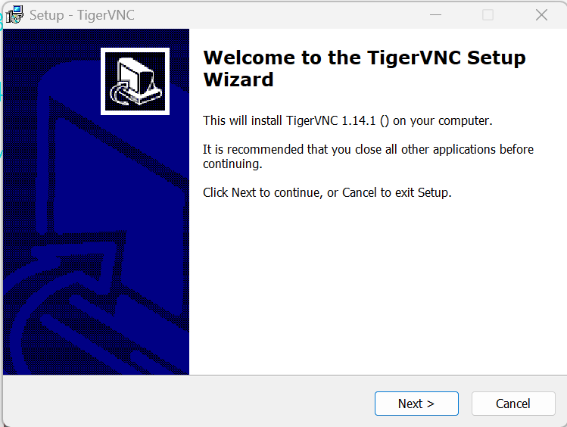

Figure TigerVNC installation

* 1. The TigerVNC application is now available on the Start Menu.

Figure TigerVNC Installed

1. There are two options for installing TigerVNC on the macOS. See below.

**Option 1: Using DMG File for macOS Installation**

1. **Download the TigerVNC DMG File**:
   * Go to the TigerVNC website and scroll down to find the latest version of the TigerVNC-*.dmg file for macOS.
   * Download the .dmg file to your computer.
2. **Install TigerVNC**:
   * Once the DMG file is downloaded, double-click it to open the disk image.
   * Drag the **TigerVNC** application into your **Applications** folder.
3. **Bypass macOS Security (if needed)**:
   * If you're using macOS 10.15 (Catalina) or later, you may see a security warning preventing the app from opening.
   * To allow the app to run, go to **System Preferences > Security & Privacy**, click the **General** tab, and click **Open Anyway** next to the TigerVNC app.
   * Alternatively, you may need to **Ctrl-click** the TigerVNC icon in your Applications folder, select **Open**, and then click **Open** again in the dialog that appears.
4. **Launch and Verify**:
   * After the security exception is cleared, launch TigerVNC from your Applications folder. You should see the TigerVNC connection window.
   * To verify the installation, try connecting to a VNC server or your own machine using the connection window.

**Option 2: Using MacPorts for macOS Installation**

MacPorts is a package management system for macOS that makes it easy to install software packages like TigerVNC.

1. **Install MacPorts**:
   * If you don't have MacPorts installed, you can download and install it from [MacPorts official site](https://www.macports.org/).
2. **Open Terminal**:
   * Launch the Terminal application on your Mac (found in the Applications > Utilities folder).
3. **Install TigerVNC**:
   * In Terminal, run the following command to install TigerVNC using MacPorts:

**bash**

**Copy code**

**sudo port install tigervnc**

* + This command installs TigerVNC using administrator privileges. You may be asked to enter your Mac's password.

1. **Verify Installation**:
   * Once installation is complete, you can verify it by running:

**bash**

**Copy code**

**vncviewer**

* + This will launch the TigerVNC viewer. If the viewer opens without errors, the installation was successful.

1. You are now ready to connect.
   1. Turn the power on to the piRover. Note the red LED indicating that power is applied and the flashing green LED light indicating activity.
   2. Allow time for the piRover to complete its boot process. The Yahboom software loads by default and you will hear four beeps indicating the Yahboom service on the piRover is ready.
   3. Open TigerVNC Viewer on your workstation.
   4. The first time you connect, you will see the following security warning. This is due to the custom SD card being built and copied many times for each student. Click “Yes” to connect.

Figure Security Exception 1

* 1. Additionally, the host name may not match the initial. Click “Yes” to make the exception and connect. You will not see these warnings in the future.

Figure Security Exception 2

1. The TigerVNC interface is displayed.

Figure TigerVNC Connection Interface

1. Enter the VNC Server address below when using the Ethernet connection. The server name (or hostname) is **piRover**. The **.local** is appended to the end due to the peer-to-peer network connection that is created over the Ethernet. Eventually you will connect via Wi-Fi and the .local specification is removed.

piRover.local

1. You must provide credentials to create the remote connection. Enter **pi** as the user and **nmc_ram** as the default password. You will continue to use pi as the user throughout the course. You will change the default password once you are connected.

Figure VNC Authentication

1. Click OK. A remote desktop is displayed.

Figure RPi Remote Desktop using VNC Viewer

1. Change the initial ***nmc_ram*** password to secure your system. Click the Raspberry in the top left corner and then click Preferences and then Raspberry Pi Configuration as shown below.

Figure RPi Menu and Configuration

1. Click the Change Password button and enter your new password. Confirming the password will activate the OK button. Click OK and then close the configuration window. **NOTE:** *You must remember your password!* There is no administrative override or ability to reset.
2. If you forget your password, you’ll need to start with a new image of the operating system, reconfigure, and then restore any project work from your cloud storage.
3. Now that the password is updated. Restart the piRover using the menu as shown below.



Figure Reboot using the RPi Menu

1. The VNC view will close the connection and attempt to reconnect.
2. Once the piRover boots, the Authentication screen will be displayed again. Enter **pi** as the username along with your new password. Click OK and the remote desktop will display.
3. The next step is to configure the piRover’s Wi-Fi connection. Open the remote desktop and locate the Wi-Fi icon in the upper righthand location on the desktop.
4. Note this double-arrow icon shown on the right side of the taskbar. This symbol indicates that there is not a current Wi-Fi connection.

Figure Taskbar showing no Wi-Fi connectivity

1. Click on this icon to select the Wi-Fi access point from the available list as shown in the image below.
   1. The instructor will review access options if you are on NMC’s campus.
      1. Guest Wi-Fi – You must open the browser on your Pi and navigate to nmc.edu. A “terms and conditions” page is shown. Click to accept using the button at the bottom of the page.
      2. NMC Wi-Fi Access Point (AP) for RAM devices. You’ll only need to set this connection once. This is new and its availability around campus is unknown at this point.
         1. SSID: **NMC-PSK**
         2. PSK/password: **Baffle-Amused-Stencil4**
   2. If you are connecting to your home access point or smartphone hotspot, you will need the required password or pass phrase.

Figure Taskbar showing sample AP connections

1. Connecting to a secure Wi-Fi access point (AP) will cause the following password prompt to be displayed. Enter the required password and click the Connect button.

Figure Wi-Fi authentication prompt

1. The icon on the taskbar will update to a typical Wi-Fi icon as shown below. Hovering over this icon will display details of your connection.

Figure Wi-Fi connected with IP details shown

1. Verify that you have an Internet connection on the piRover by launching the browser using the icon on the taskbar and navigating to Google.com. The Google search page should load.

Figure Browser with Google page loaded

1. A more common way for a developer to check for an Internet connection is to “ping” a server. Open a terminal window and enter the following command. This “pings” the Google name space server at 8.8.8.8. If your connection is good, you will see replies as shown below. Close the window or use Ctrl+C to stop.

**ping 8.8.8.8**

Figure Ping command showing replies

## Assessment:

Your instructor will discuss any assessment action due at this time. You must be able to remotely connect to the piRover. All future piRover class activities are dependent on this remote connection.